**Experiment 2**

**Aim:** Extend the User profile Application which allow user to select the Material Status and Hobbies.

**Code:**

1. **Webform1.aspx:**

<%@ Page Language="C#" AutoEventWireup="true" CodeBehind="WebForm1.aspx.cs" Inherits="Lab2.WebForm1" %>

<!DOCTYPE html>

<html xmlns="http://www.w3.org/1999/xhtml">

<head runat="server">

<title>Employee Registration</title>

<style type="text/css">

#TextArea1 {

height: 257px;

width: 460px;

}

</style>

</head>

<body>

<form id="form1" runat="server">

<div>

<p>

Employee ID:&nbsp;

<asp:TextBox ID="TextBox1" runat="server"></asp:TextBox>

</p>

<p>

First&nbsp; name:&nbsp;

<asp:TextBox ID="TextBox2" runat="server"></asp:TextBox>

</p>

<p>

Last name:&nbsp;

<asp:TextBox ID="TextBox3" runat="server"></asp:TextBox>

</p>

<p>

Date Of Birth:&nbsp;

<asp:TextBox TextMode="Date" ID="TextBox4" runat="server"></asp:TextBox>

</p>

Gender:

<asp:RadioButtonList ID="RadioButtonList1" runat="server" DataTextField="Gender" DataValueField="Gender">

<asp:ListItem>Male</asp:ListItem>

<asp:ListItem>Female</asp:ListItem>

<asp:ListItem>Other</asp:ListItem>

</asp:RadioButtonList>

<p>

Marital Status:

<asp:RadioButtonList ID="RadioButtonList2" runat="server" DataTextField="MaritalStatus" DataValueField="MaritalStatus">

<asp:ListItem>Married</asp:ListItem>

<asp:ListItem>Unmarried</asp:ListItem>

</asp:RadioButtonList>

</p>

<p>

Hobbies:

<asp:CheckBoxList id= "checkboxlist1" AutoPostBack = "true" TextAlign = "Right" runat= "server">

<asp:ListItem> Reading</asp:ListItem>

<asp:ListItem> Writting</asp:ListItem>

<asp:ListItem> Walking</asp:ListItem>

</asp:CheckBoxList>

</p>

<br />

<p>

<asp:Button ID="Button1" runat="server" Text="Register!" OnClick="RegisterUser" />

</p>

</div>

</form>

<div id ="Result”>

<textarea id="TextArea1" name="S1" runat="server"></textarea>

</div>

</body>

</html>

1. **Webform1.aspx.cs:**

using System;

using System.Web.UI.WebControls;

namespace Lab2

{

public partial class WebForm1 : System.Web.UI.Page

{

protected void Page_Load(object sender, EventArgs e)

{

}

protected void RegisterUser(object sender, EventArgs e)

{

string Eid, Fname, Lname, DOB, Gender, Marital_Status, Hobies;

Eid = TextBox1.Text;

Fname = TextBox2.Text;

Lname = TextBox3.Text;

DOB = TextBox4.Text;

Gender = RadioButtonList1.SelectedValue;

Marital_Status = RadioButtonList2.SelectedValue;

if (checkboxlist1.SelectedIndex >= 0)

{

string state1 = "";

foreach (ListItem s in checkboxlist1.Items)

{

if (s.Selected)

{

state1 += s + ",";

}

}

state1 = state1.Substring(0, state1.Length - 1);

Hobies = state1;

}

else

{

Hobies = "";

}

String ans = "Employee id: " + Eid + "\nFirst Name: " + Fname + "\nLast Name: " + Lname + "\nDOB: " + DOB + "\nMarital Status: " + Marital_Status + "\nGender: " + Gender + "\nHobbies: " + Hobies;

TextArea1.InnerText = ans;

}

}

}

**Output:**

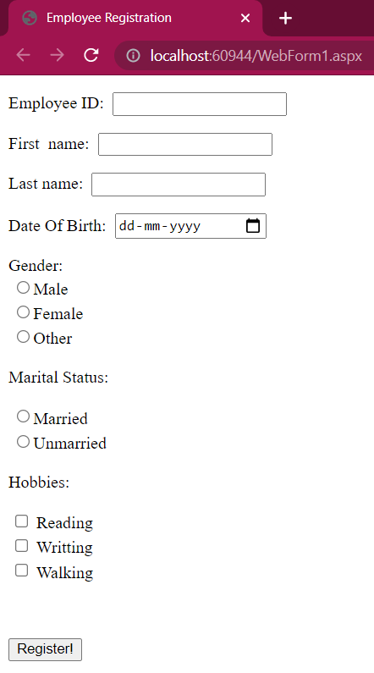

Fig.1 Simple register Form

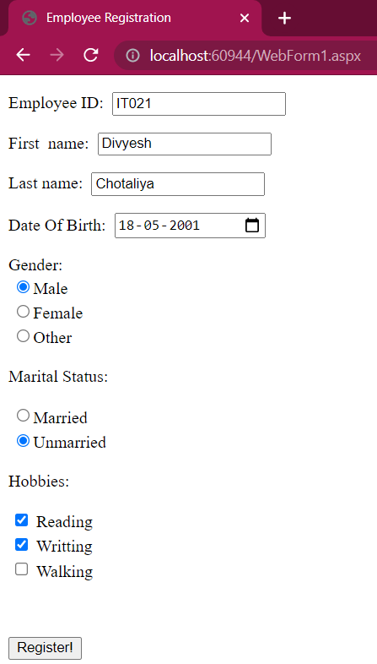

Fig2. Inserting details

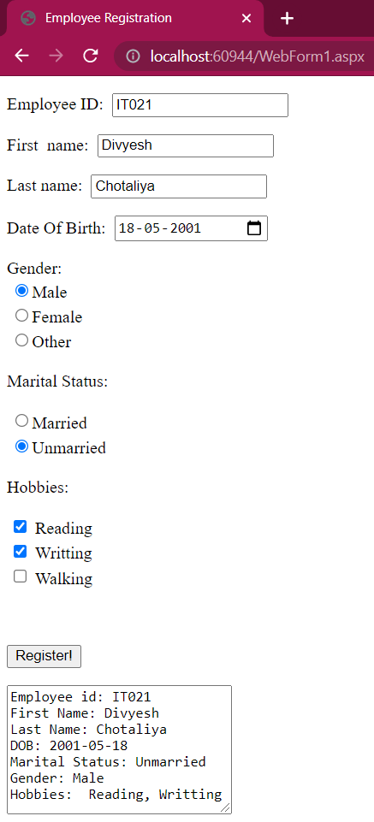

Fig 3. Displaying Output